**School of Computer Science**

**UNIVERSITY OF PETROLEUM AND ENERGY STUDIES DEHRADUN, UTTARAKHAND**



System Provisioning And Configuration Management

Lab File (2022-2023)

for  
6th Semester

**SUBMITTED TO SUBMITTED BY**

DR. HITESH KUMAR SHARMA Alisha Parveen

B.TECH CSE – 6th SEM

DEVOPS - BATCH 1

500091204

**Lab Exercise 1– Install Terraform on Windows**

Installing Terraform on Windows requires you to download the correct Terraform package, unpack,

and execute it via the CLI.

1. Installing Terraform for Mac Via Brew

* Command 2 – brew install hashicrop/tap/terraform

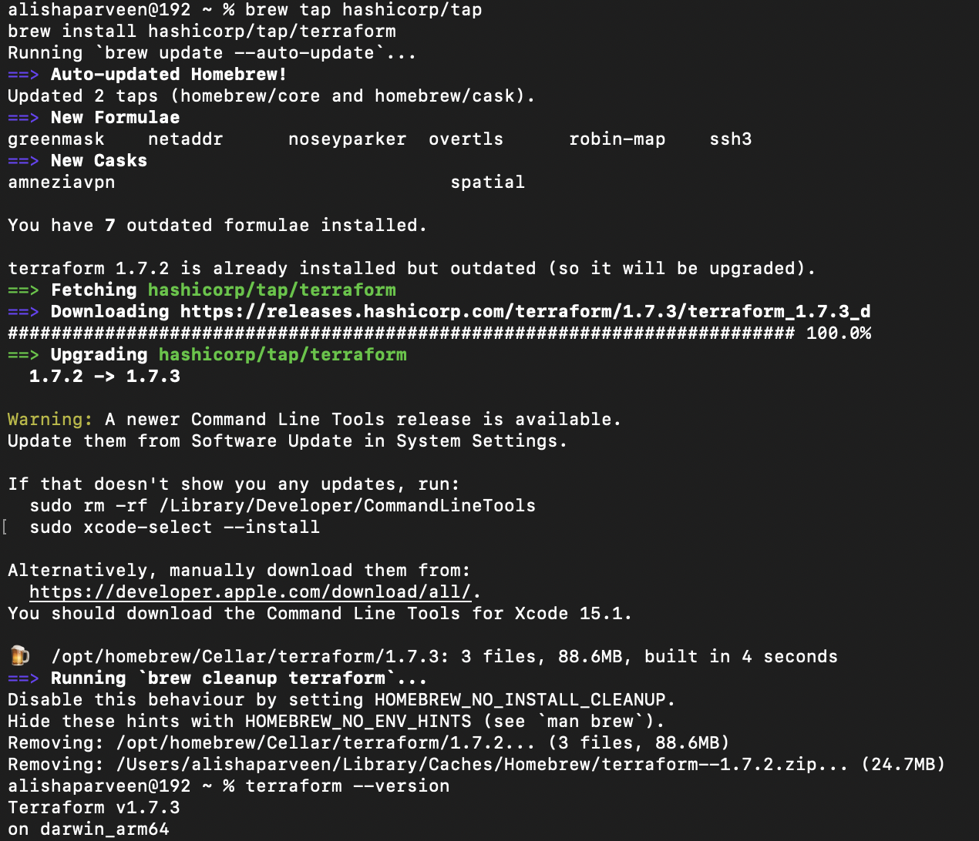

1. Checking for version

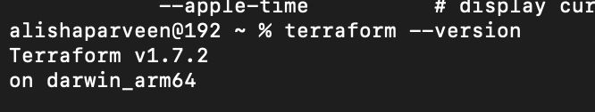

**Lab Exercise 2– Terraform AWS Provider and**

**IAM User Setting**

**Step 1: Create a New Directory:**

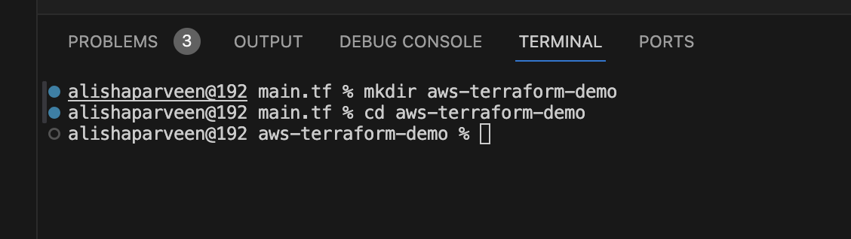

**Step 2: Create Terraform Configuration File (main.tf):**

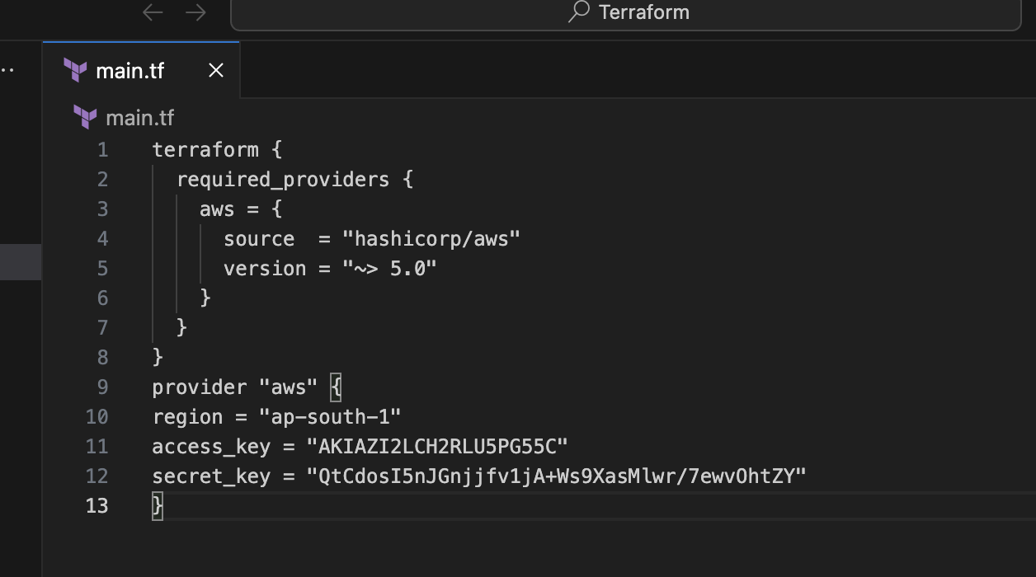

**Step 3: Initialize Terraform:**

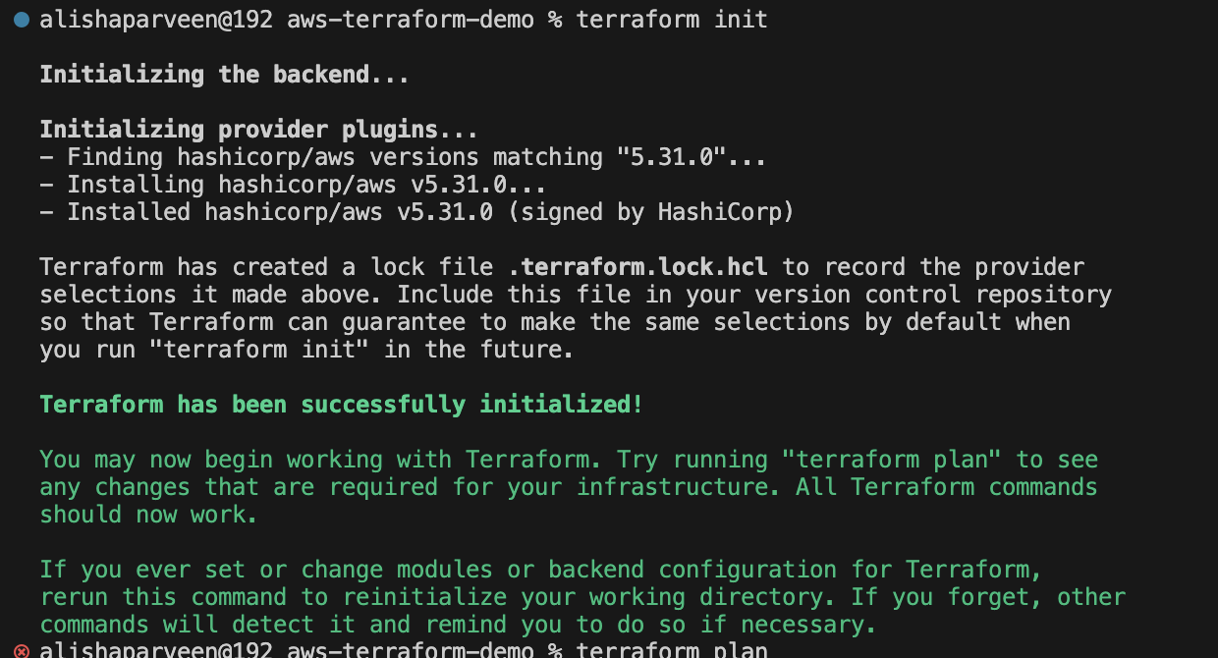

**Lab Exercise 3–Provisioning an EC2 Instance on**

**AWS**

**Step 1: Create a New Directory:**

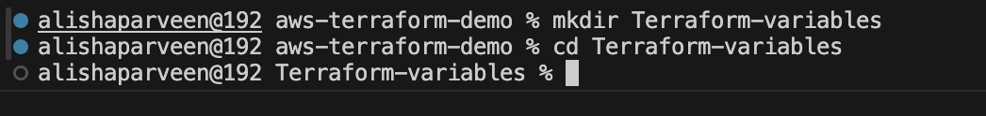

**Step 2: Create Terraform Configuration File (main.tf):**



**Step 3: Initialize Terraform:**

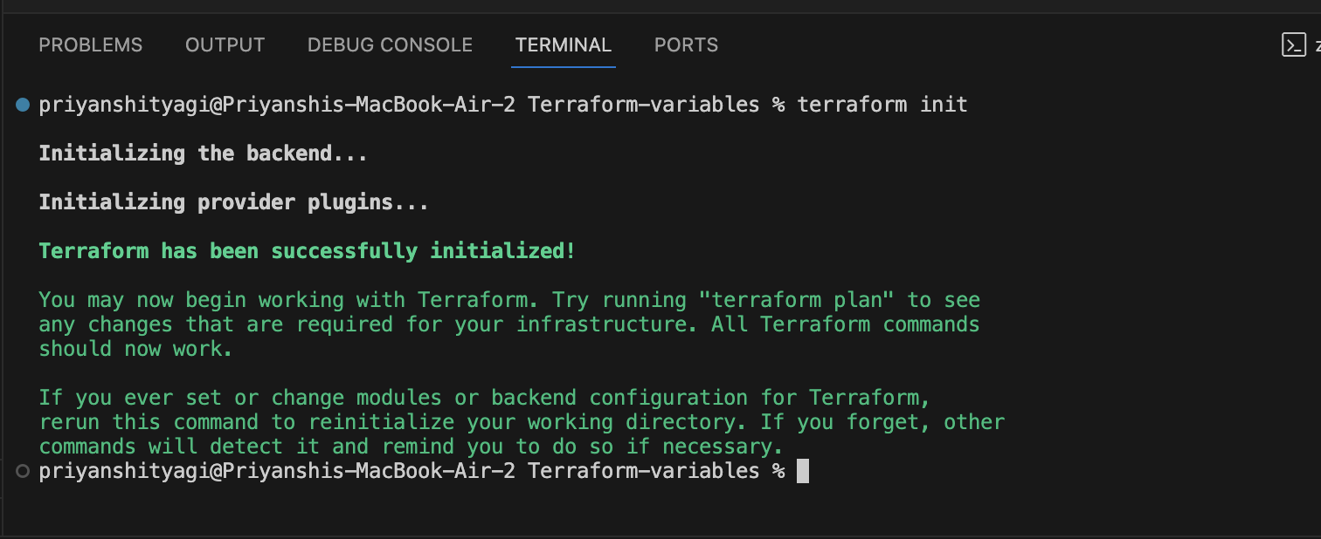

**Step 4: Create Terraform Configuration File for EC2 instance**

**(instance.tf):**

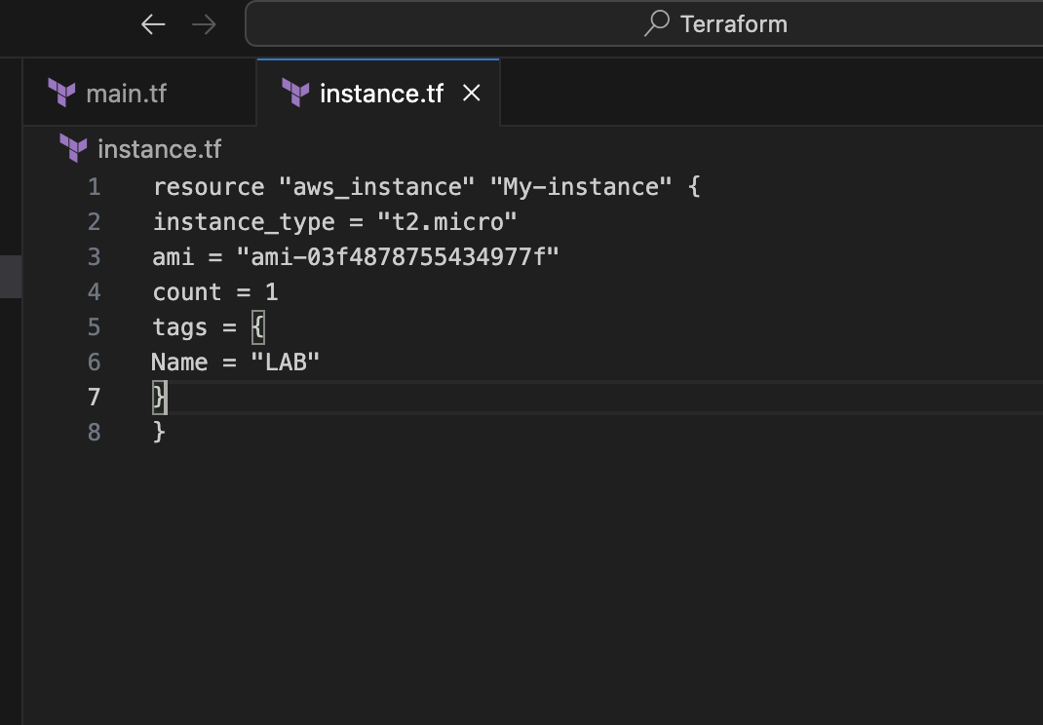

**Step 5: Review Plan:**

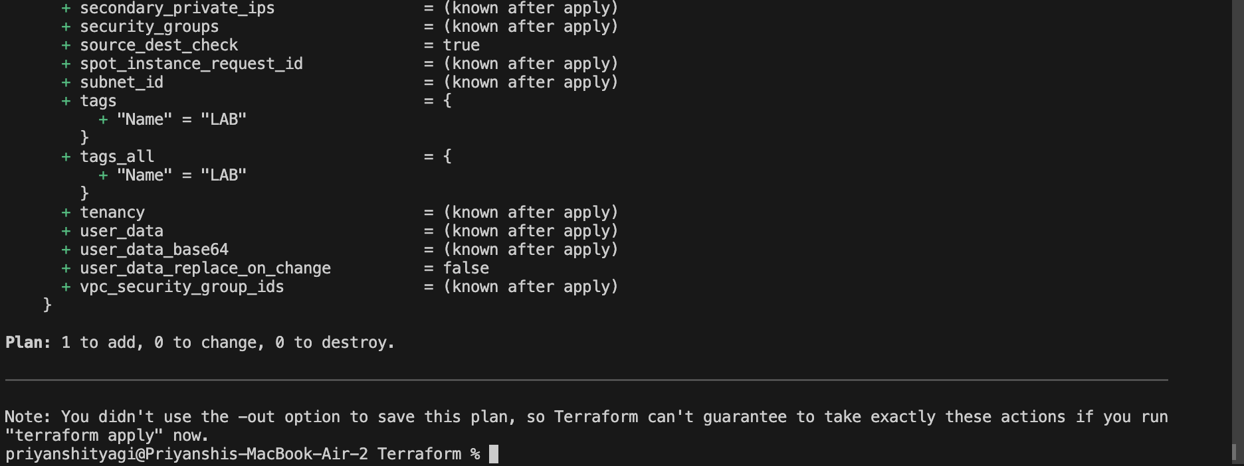

**Step 6: Apply Changes:**

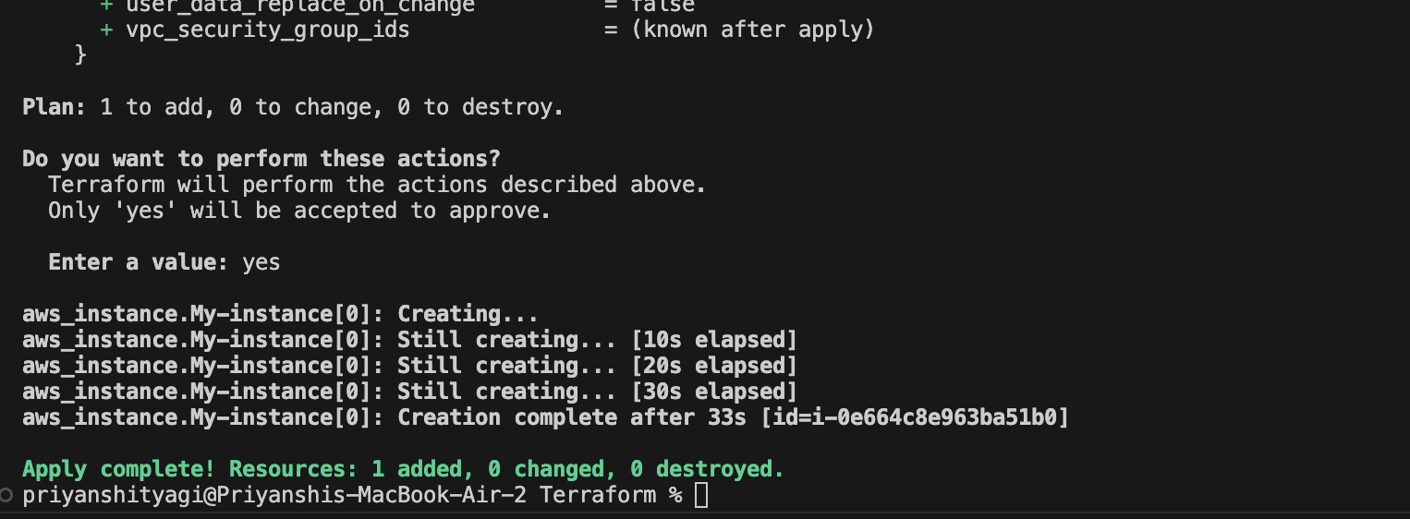

**Step 7: Verify Resources:**

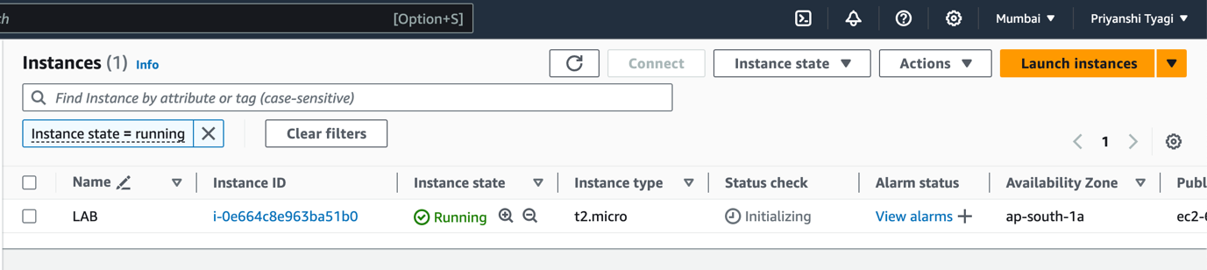

**Step 8: Cleanup Resources:**

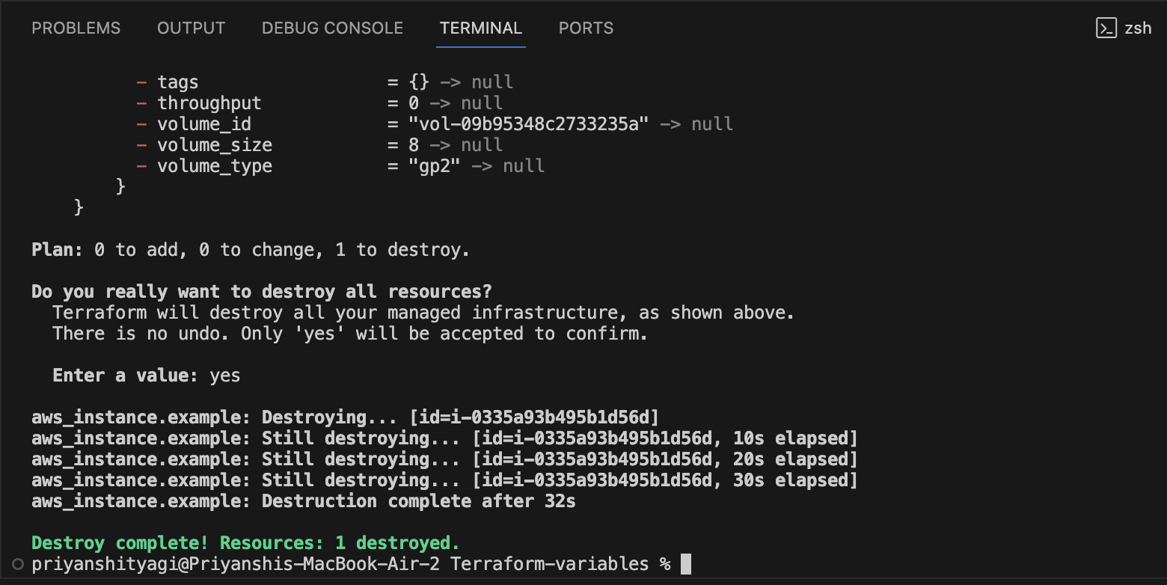

**Lab Exercise 4– Terraform Variables**

**1. Create a Terraform Directory:**



**2. Create a Terraform Configuration File:** 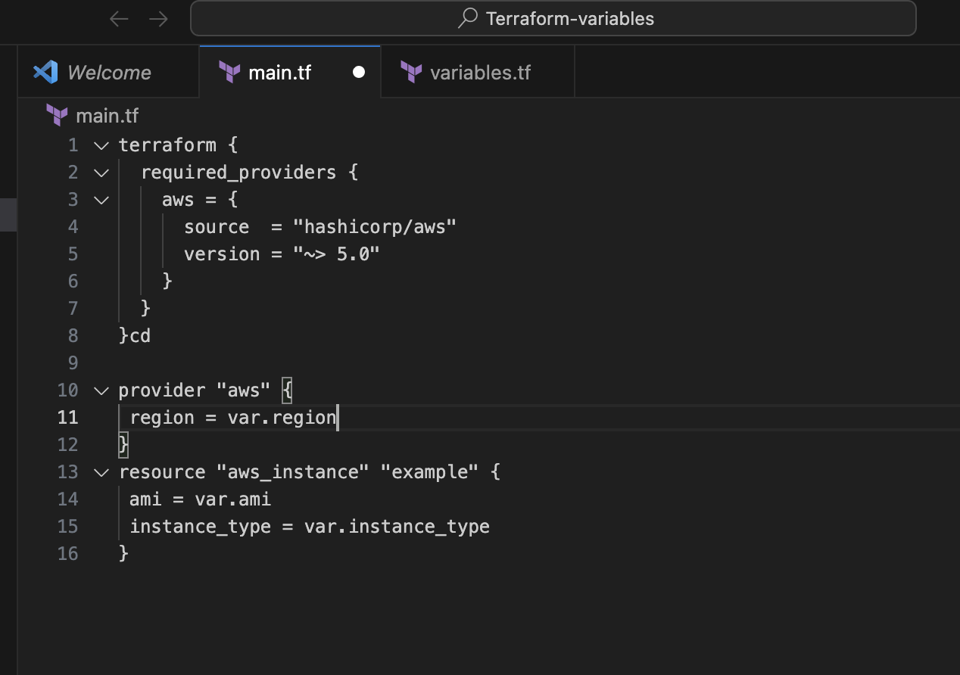

**3. Define Variables:**

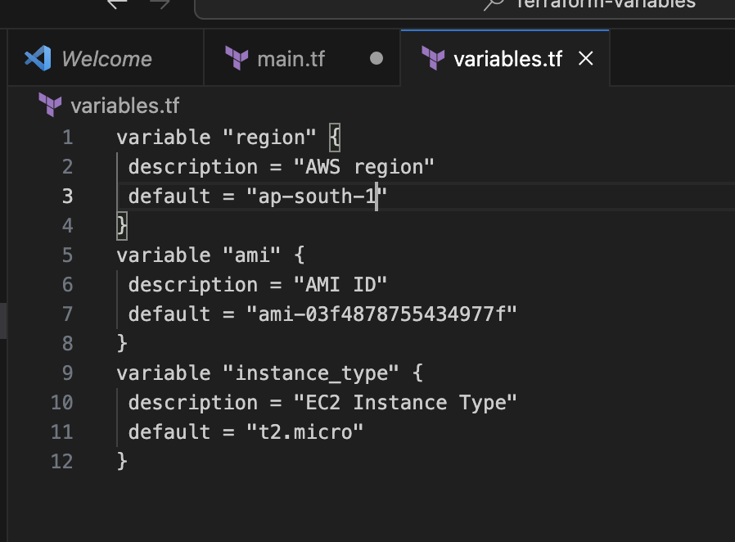

**4. Initialize and Apply:**

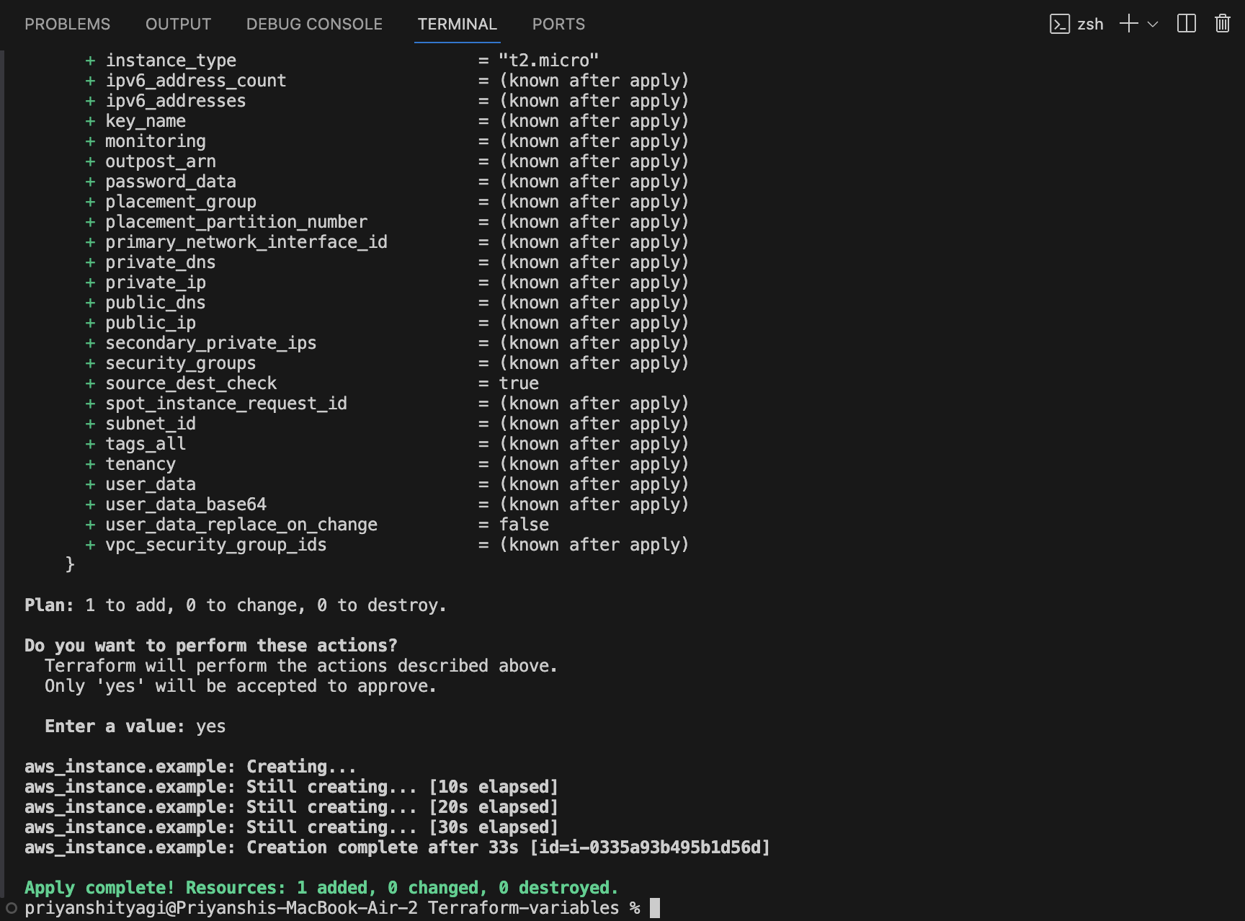

**5. Verify**

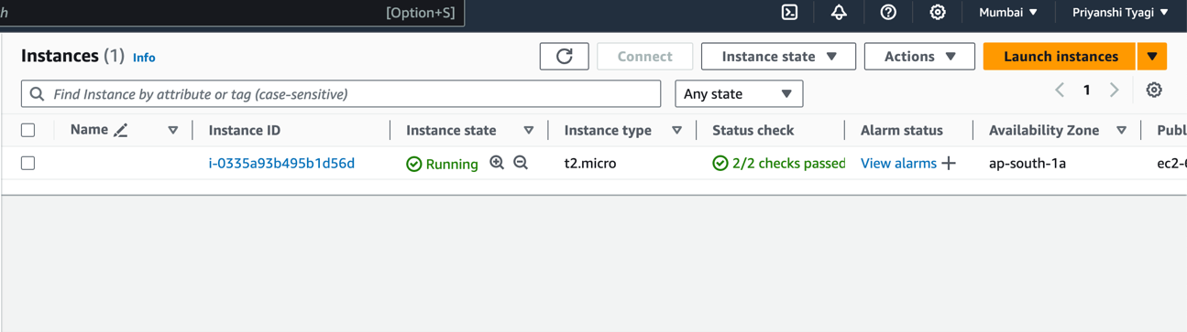

**6. Clean Up:**



**Lab Exercise 5– Terraform Variables with Command**

**Line Arguments**

**1. Create a Terraform Directory:**



**2. Create Terraform Configuration Files:**

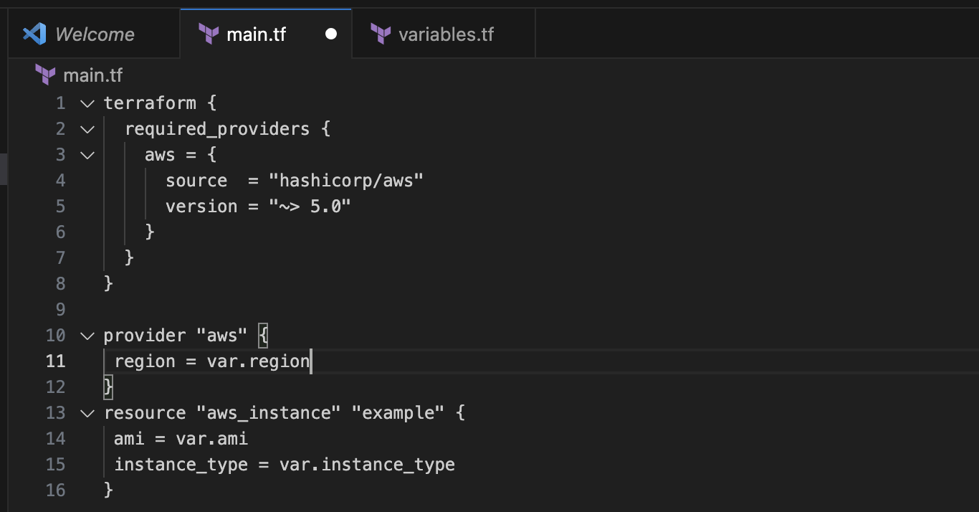

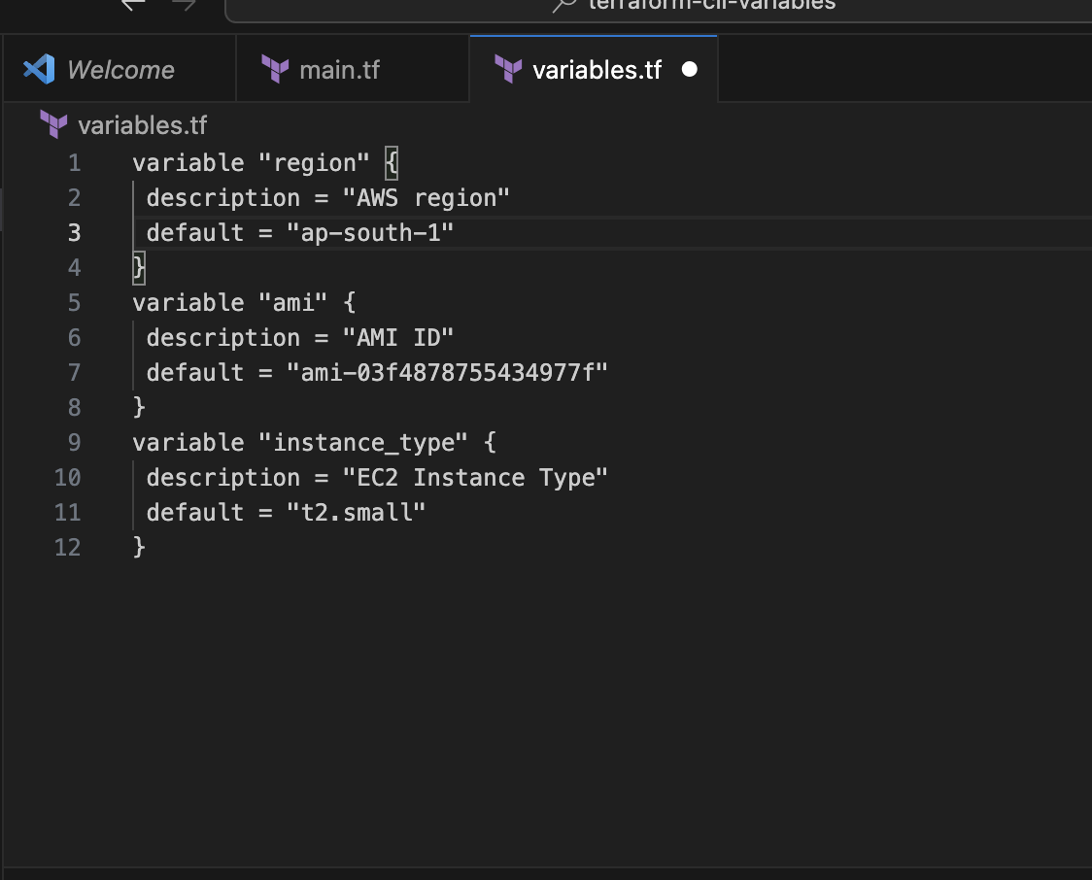

**3. Use Command Line Arguments:**

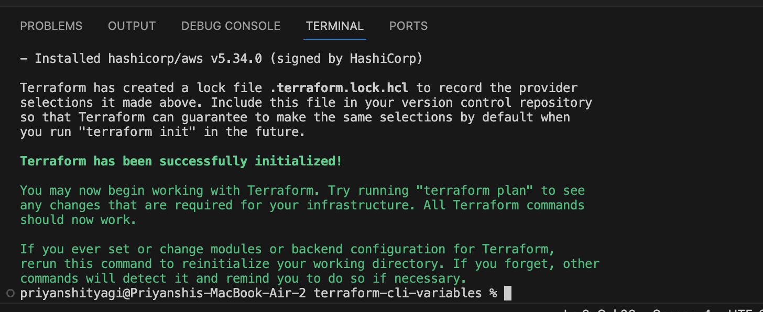

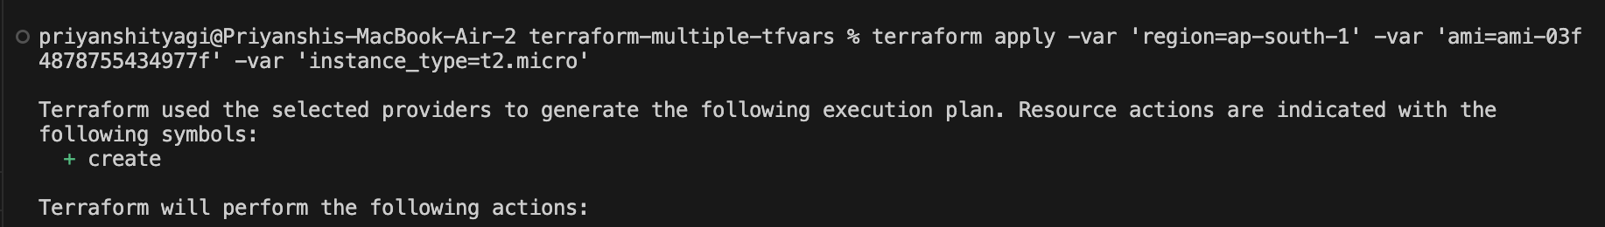

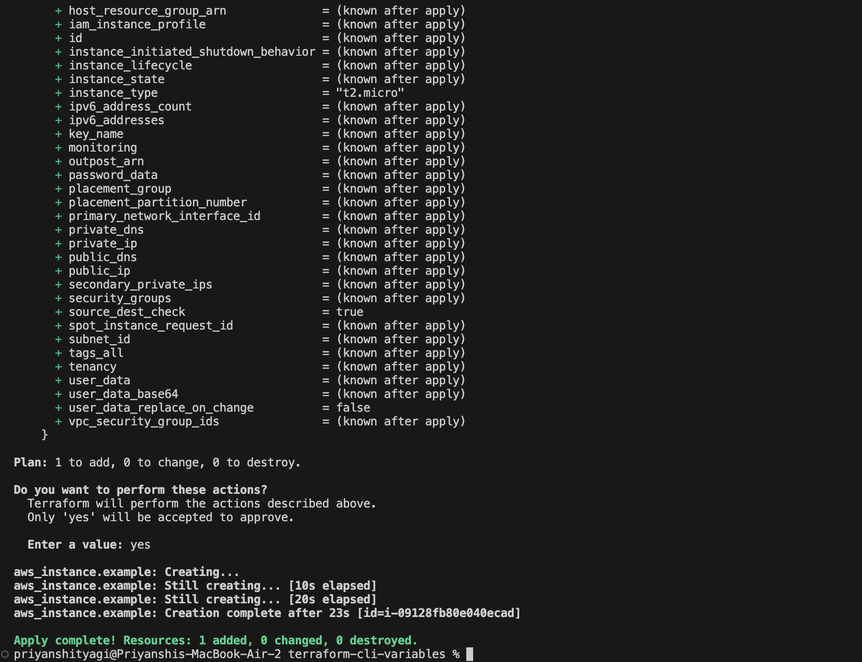

**4. Test and Verify:** 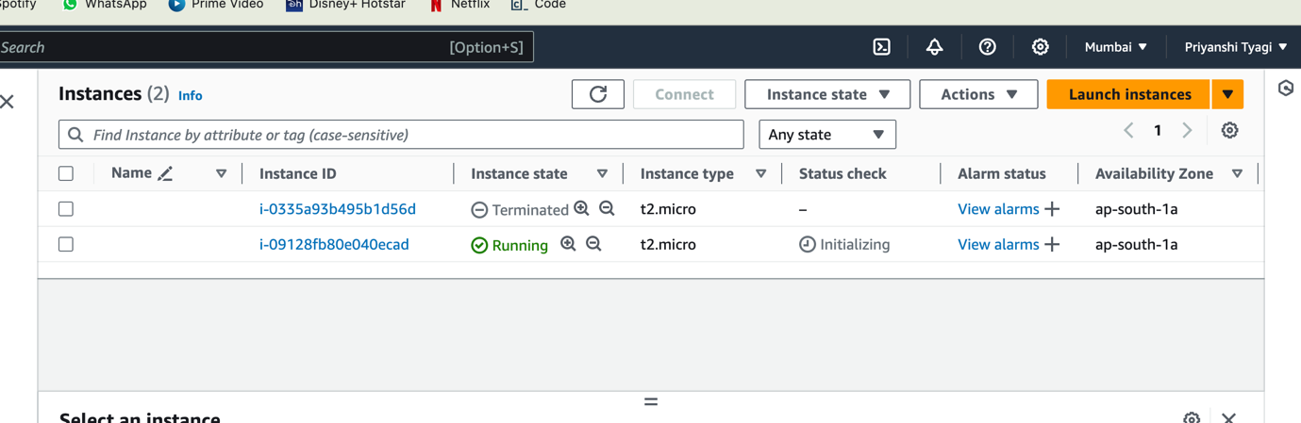

**Lab Exercise 6– Terraform Multiple tfvars Files**

**2. Create Multiple tfvars Files:**

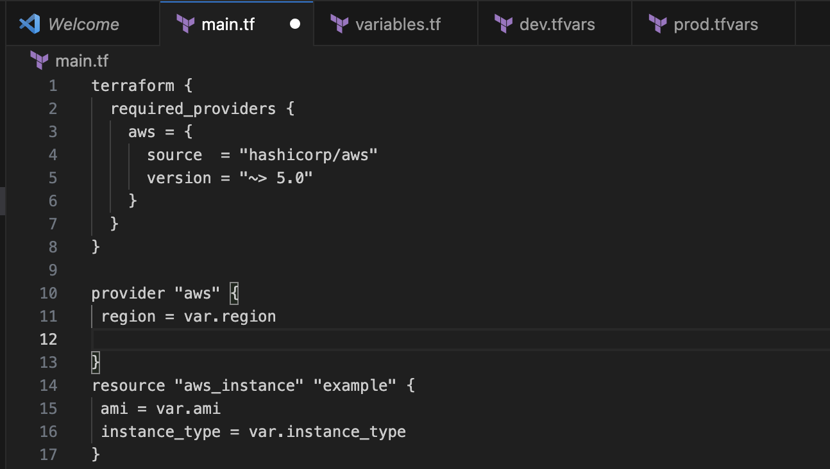

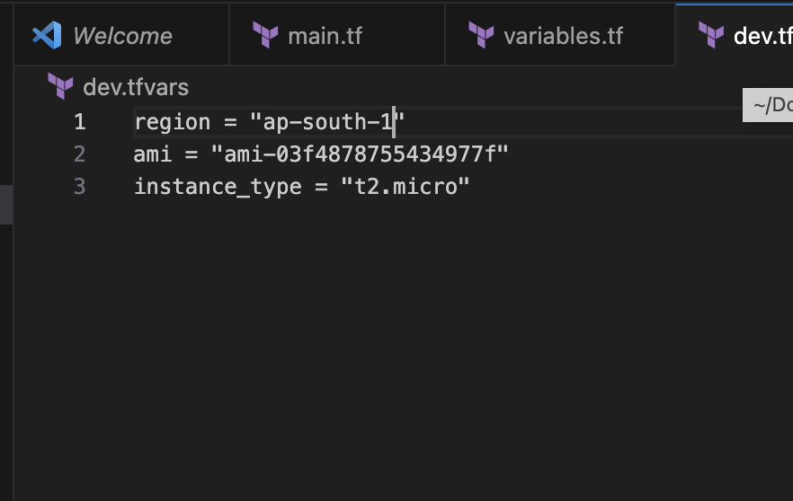

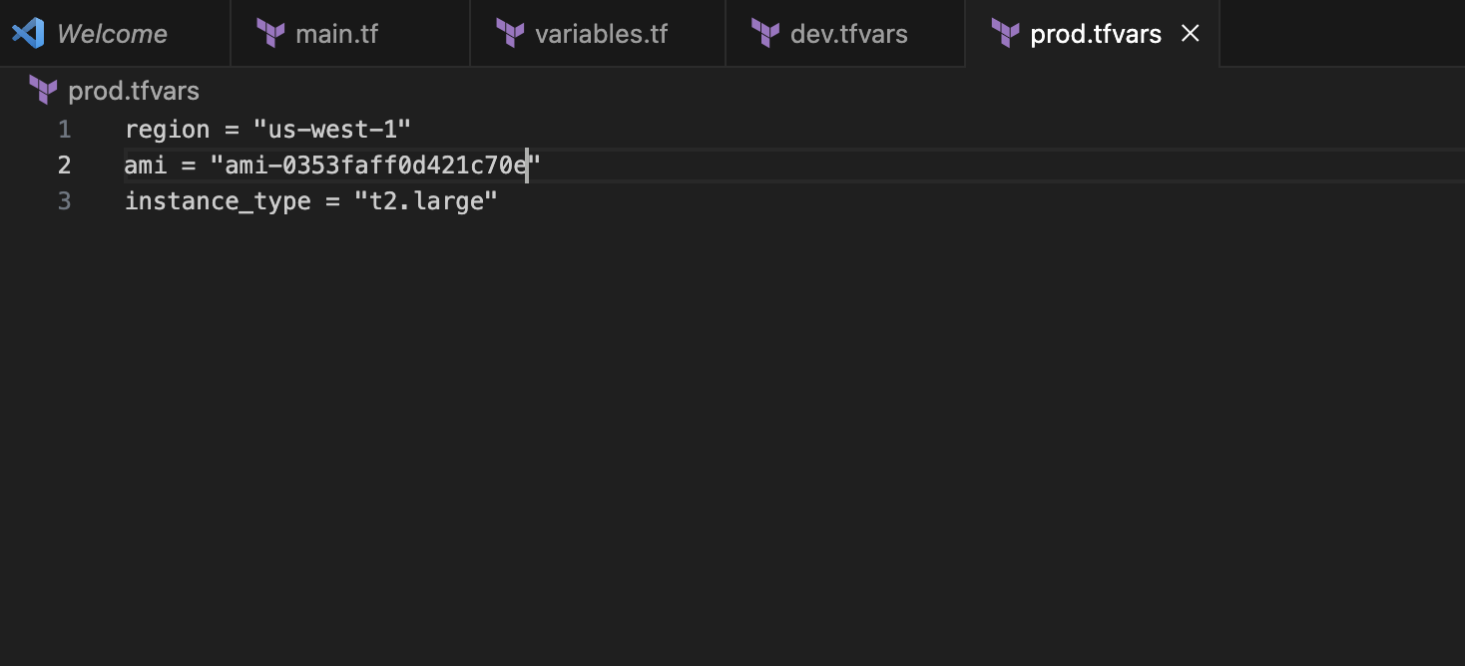

**3. Initialize and Apply for Dev Environment:** 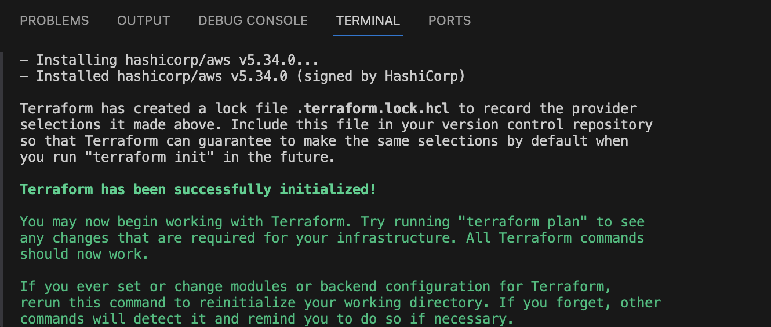

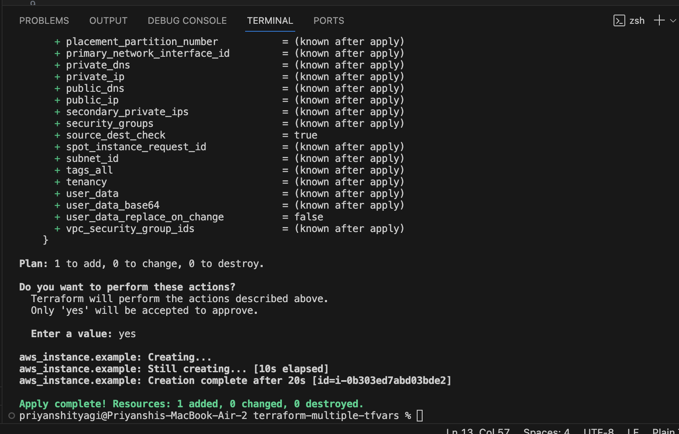

**4. Test and Verify:** 